What’s New?
I now can devote 100% of my time to my art after a 32 year graphics career. It is wonderful.
Since then, I’ve been fortunate enough to show at many galleries, including a sold out show in California and a show in New York and Vancouver. There are now 5 galleries showing my work in the south

Snapshot
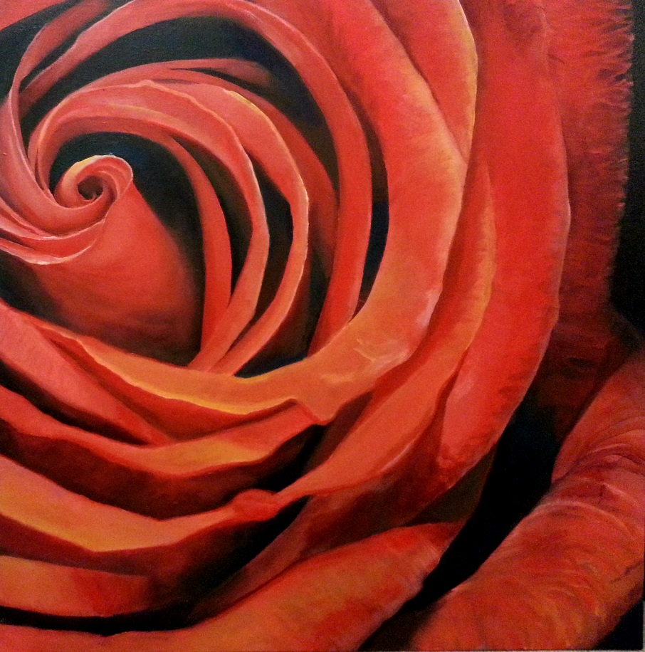
Bloom 36’ x 36’

What inspires you today?
Experience is everything to moving forward. I’ve had the opportunity to meet many fine artists over the past five years. The same concepts and attitudes that move any art lover moves me also. It has been fantastic to take that into the creative process. As far as subject matter, small things imagined as big things continue to interests me.

What should folks expect to see from David Wendel this year?
After exploring various media and paint application, there is a renewed, long term focus on realism.
I have one piece completed in a series of six or so large paintings (4’ x 6’) based on photographs taken at beaches over the past few years.

What would you tell people who haven’t seen your work lately?
I’ve had a lot of fun learning different subject matter and execution the last year or two. That learning curve had to happen. Using larger brushes, for example, was an invaluable experience. Each of the galleries featuring my work has its own vibe, so that keeps it interesting. The subject matter alternates, but style and execution are the commonality. Early training at “The Norman Rockwell School” pushed the realism, blended with a personal hunger for the Impressionists. Focusing on the realism in a set series of pieces gives me both a guidance and clarity of purpose currently needed in the work.

What is your favorite piece and why?
The one I’m working on.

Define the art scene in Marietta and Cobb County?
It’s too diverse to be definable. From the Art Walks to the Marietta Cobb Museum, there’s an incredible range. The Mable House Arts Center in Mableton is incredible resource. We have smaller venues that trade work from Monet to Warhol. The concerts on the square coming up are a real family event. It’s an amazing time to live here. It’s really vibrant and alive.

How active are you and the gallery supporting new artists? What’s new on that front?
Donna Krueger has enabled any artist in the area to show in the Artist’s Market during the Art Walk festivities. Donna organized so much of that. It’s a great way to meet the new artists entering the market. The Marietta/Cobb Museum sponsors numerous shows available to local artists, making that a fantastic addition to the local art scene. As for me, I do my best to encourage and welcome all artists of all disciplines achieve their own unique space in our community.

What can Cobb residents do to help support the arts? Local charities?
Get involved. Indulging in the creative stimulates the senses, makes your mind and spirit meld together. Music, painting, design, Cobb really has it all. The Marietta/Cobb Museum has great classes available for the arts. Take a class! Get involved.
It would be great for a Cobb based charity to allow artists to donate artwork for a silent auction fundraiser. It works so well for the “ArtCan” event in Atlanta, and other charitable organizations around the country. The auction provides a very personal way for artists to give back to their community.

How cool is it to be part of Cobb’s growing art community?
It’s an honor to be part of this vibrant group of artists! I feel very much part of the community. My wife Kate and I have lived in Cobb for 35 years, raising two boys, so its home. To be able to devout my total time to it has been immensely satisfying

