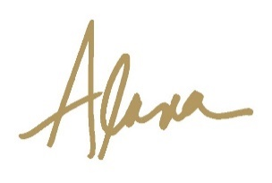

CORE CONCEPTS OF PORTRAIT PAINTING
WORKSHOP at Quinlan Art Center
March 14, 15 and 16, 2019
10 AM to 4 PM

MATERIALS LIST

Adjustable easel
Small table or cart for painting supplies
One 18 x 24 oil primed canvas (stretched or panel) – suggest Blick Belgian Linen Archival Panel.
One 16 x 20 canvas panel – economy grade
One 12 x 18 charcoal pad of white paper
Chamois
Vine charcoal and/or charcoal pencils
Kneaded eraser
Oil paints: Brands - Holbein, Gamblin, Winsor Newton
Titanium White | Ivory Black
Transparent Red Oxide | Yellow Ochre
Chromium Oxide Green | Winsor Red or Cadmium Red
Dioxazine Violet | Ultramarine Blue
TYPE | BRUSH WIDTH
Flat Bristle or synthetic – one each size | 1”, ¾”, ½”
Filbert Synthetic/Sable Combo  one each size | ¾”, ½”; 3/8”; ¼”
Round Sable - two | (No. 1)
Fan Synthetic/Sable - one
Palette knife - one | 3/8” wide x 1 ½” long  (small diamond shape”

Brushes: Brands of brushes are numbered differently, so measure across the belly. Long handles are preferred for oil. 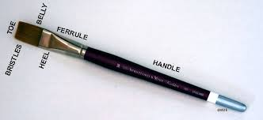

Mediums: Odorless turpentine, walnut or linseed oil
Palette, paper towels, trash bags, rags, sealable glass containers for mediums, small mirror
Comfortable shoes

