ANN MOELLER STEVERSON
Oil on Copper Workshop
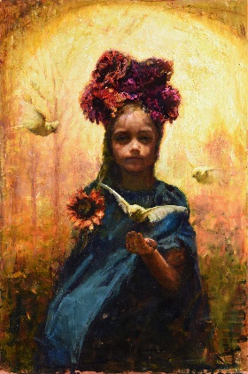
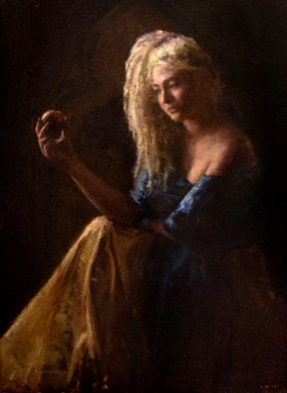
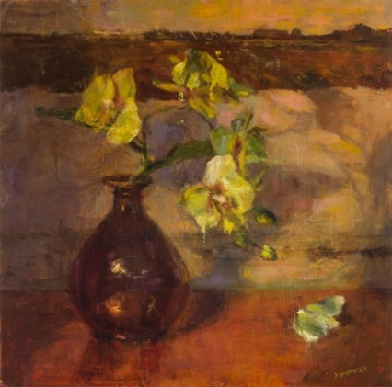

“Never ignore your passion. Allow yourself to be free with your art. Believe in your own greatness, and find the voice within” –Ann Moeller Steverson.
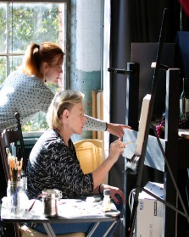
Ann Moeller Steverson, an experienced painting instructor, is available to teach a workshop in your area. She specializes in training beginner to advanced artists in classical art foundations of oil painting. Ann teaches regularly in Huntsville, AL, where she is a part of a close-knit artist community at Lowe Mill ARTS & Entertainment. There, with two fellow artists, c0-founded Protégé Atelier, in order to bring master level artist workshops to Huntsville. In addition, after discovering the joy of painting on copper, Ann invented- VENUS COPPER PANELS, the first Copper Composite Artist Panel.
Workshop Description- Enjoy learning the joys and methods of oil painting on copper, this new version of a classical support, developed by the artist herself. Ann will walk you through the specifics of painting on copper, classical painting techniques and proper materials use. We will have a morning for experimenting with materials and an instructed still life in the afternoon.
Bio- Ann Moeller Steverson, known for her mood filled figures, portraits, and still-life, began painting in oils at the University of Montevallo in 1999. She graduated in 2002 from the University of Alabama in Huntsville, completing a B.A. with a Fine Arts Concentration, and then acquired a Masters of Art Education from Alabama A&M University in Normal, Alabama. Ann has been awarded the honor of the Bold Brush Award, a distinction an artist may achieve only once in their lifetime. Her work has recently been selected as a finalist in the Art Renewal Center, been featured in several Oil Painters of America exhibits, and has been awarded by the National Acrylic and Oil Painters Society, and Portrait Society of America.

“Painting with oils on copper is a special experience. Copper as a support gives off an iridescence and has a perceptible depth that you just can’t get from wood or canvas. Artists such as Quang Ho have said - “it’s delicious to paint on” and “it’s like butter.” I would very much like to share this beautiful material with you. Let’s gather artists in your community and come together for an enjoyable fun 1 day workshop.”

WORKSHOP SPECIFICS

Duration- 1 Days
Cost- Suggested $160 per person registration fee, plus $20 per person material fee. 50% registration fee for the instructor plus travel.
Maximum Attendants- Up to 20 depending on space
Minimum Attendants- 8
View more of Ann Moeller Steverson’s work at:
http://www.annmoellerstudios.com/

WORKSHOP REQUESTS

Classroom: about 800 sq. feet (fewer windows and/or light control preferred)
• Folding chairs
• Folding tables
• 3 or 4 Still life setups
• Light stands (to hold a light in a proper location to illuminate the still life objects)
• Extension cords
• Still life objects (pots, jars, bottles, fruit, and flowers)
• Draperies
• A music player (optional
• Trash cans and bags
• Spotlight bulbs
• Easels and side tables (note: if not available add to student supply list)

WORKSHOP MATERIALS NEEDED
1. Bristle Brushes (long handled) - #10 Filbert or flat #6 filbert, #4 round or filbert, #2 Flat or filbert Brand: Rosemary or Windsor Newton
2. Sable, mongoose or Synthetic Brush (long handles if possible)- #0 round, #1round, #2 Filbert or Round #4 Filbert or Round
3. Metal Palette knife
Paints: Yellow Ochre, Cadmium (or substitute Permanent for cadmiums) Yellow Light, Cadmium Orange, Cadmium Red Light, Alizarin Crimson, Permanent Rose, Transparent Oxide Red (or Burnt Sienna), Transparent Oxide Brown (or Raw Umber) Ultramarine Blue, Cobalt or Cerulean Blue, Manganese Violet,
Sap Green, and Titanium White or Lead White.
I like Rembrandt and Gamblin and Natural Pigments oil colors, but other artist grade brands are fine too.
Medium: Linseed or walnut oil. Gamsol or other odorless mineral spirit. Please no turpentine.
Palette: No specific requirement. A piece of glass over a piece of brown paper or wood. If
you like a one-time-use paper palette, use the gray color one, not white.
Support: Copper panels will be supplied with materials fee by instructor.
Viva Paper towels

