Jason M. Smith
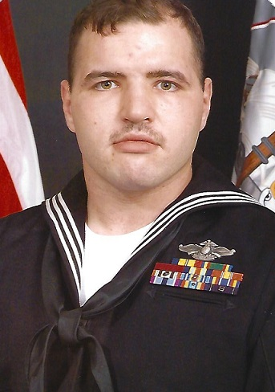
Jason was born on a Marine Corps installation in Southern California in 1982 to parents William and Loretta Smith. He has a younger sister named Tanya, and a younger brother named Chris. The family moved from California in 1987 to his father’s hometown of Walnut Cove, N.C. That is where Jason spent the remainder of his childhood.
In 2001, Jason graduated high school, and went straight into the United States Navy as a Hospital Corpsman. He was stationed with a Marine Corps Unit in Camp Lejeune, N. C. as a combat medic. He served two tours of duty in Iraq with 1st Battalion, 8th Marines.
On his second deployment, Jason’s unit was involved in Operation Phantom Fury. It was the second battle for the city of Fallujah, and is considered the largest battle of the Iraq war.
In 2010, Jason met his wife Pam who was a native of Gainesville, G.A. In 2013 they moved from North Carolina to Gainesville, G.A. After getting to Georgia, he began to paint in the summer of 2013. He was curious as to whether or not his art would sell, so he took it to a local folk art gallery. There he was given the chance to attempt to sell his art, and also guidance and advice from the shop’s owner.
Jason has never had a lesson, or any sort of formal training in art. He is a completely self-taught artist. Making art has been a great asset and outlet for him over the five years.
Jason battles severe combat PTSD (Post Traumatic Stress Syndrome) and is no longer able to work. He uses his art as a therapy tool, along with treatment from his local VA Hospital, to help him in his daily battles with this disorder. He hopes that trough his art, not only can he obtain some solace, but that he can touch other people’s hearts as well. Also, he hopes to be an inspiration to other veterans and service members who deal with the same disorder, so that through his experiences, they can see that PTSD does not have to rule their lives.

