VILAS TONAPE SUPPLY LIST
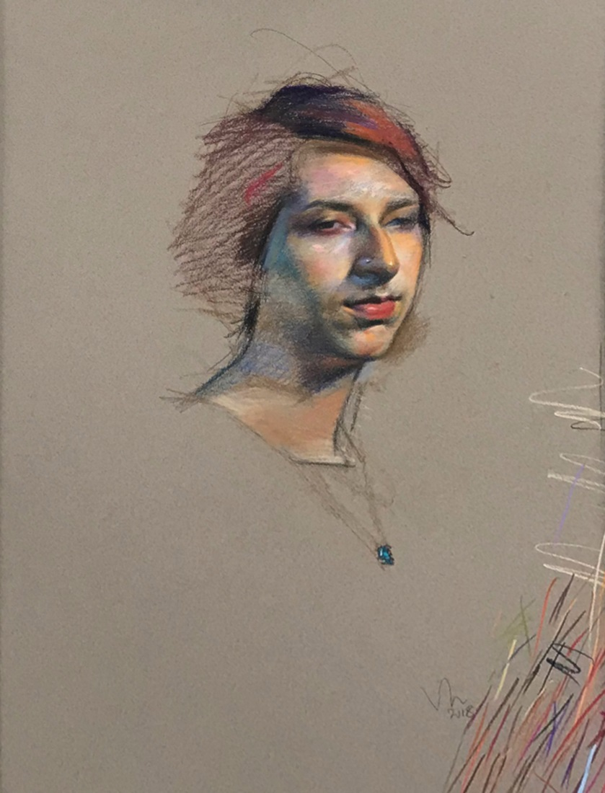
A portfolio folder to carry drawing papers
• Felt Gray (or Steel Gray, if Felt Gray is not available) shade, 19 x 25 inch, Canson MiTeintes drawing papers only (5-7 sheets)
• Drawing board (preferably a simple masonite board) to hold 19 x 25 inch paper (one
board per participant)
• One roll of masking tape
• Prismacolor brand NuPastel 36 Color Sets only (one box per participant)
• One HB, one 2B and one 4B charcoal pencil
• One yardstick (cost about 82 cents at Home Depot or Lowes)
• A tackle box-like case (art box) to carry supplies (optional)

